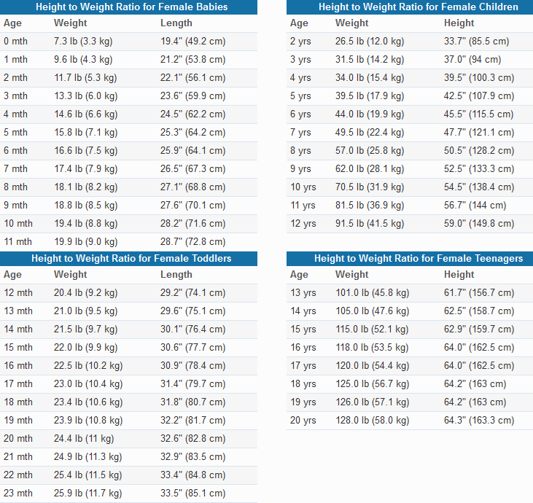
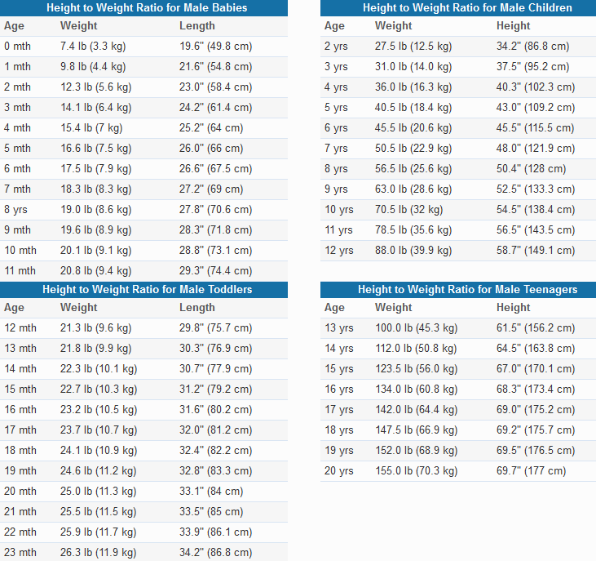
*Information and data for above growth charts sourced from The World Health Organization (WHO), Gerontology Research Center (National Institutes of Health, USA), and the U.S. Centers for Disease Control and Prevention (CDC).

